**IT2120 – Probability and Statistics**

**Lab Sheet 07**

**IT24102701**

**Abayawardena W.A.A.U**

**Exercise**

1. A train arrives at a station uniformly between 8:00 a.m. and 8:40 a.m. Let the random variable X represent the number of minutes the train arrives after 8:00 a.m. What is the probability that the train arrives between 8:10 a.m. and 8:25 a.m.?

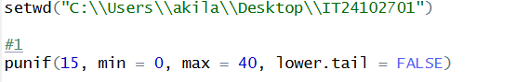

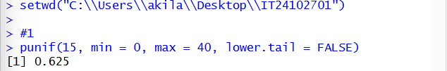

1. The time (in hours) to complete a software update is exponentially distributed with rate

λ = 1 3 . Find the probability that an update will take at most 2 hours.



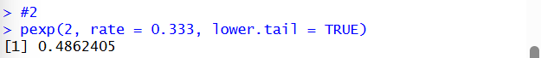

1. Suppose IQ scores are normally distributed with a mean of 100 and a standard deviation of 15.
2. What is the probability that a randomly selected person has an IQ above 130?

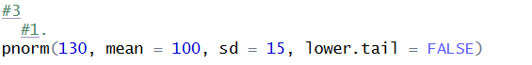

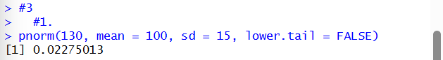

ii. What IQ score represents the 95th percentile?



